Supplementary Table 1. Categorization of study patients according to the International Classification of Diseases (10th version).
Process | Diagnosis | ICD-10 code
Exclusion | Frost injury | T33–T35
 | Hypothermia | T68, T69
 | Drowning | T751
 | Heat related illness | T67
 | Burn | T20–T32
Subgroup | Infection | A00–A99, B00–B99, G00–G09, J00–J18, J36, J440, J85, J86, K29, K35–K37, K57, K61, K65, K80, M00–M02, N10, N41, N45, N61, N70–N74, R65
 | Cerebrovascular accident | I60–I69
 | Traumatic brain injury | S02–S08, S06–S08

Supplementary Table 2. Categorization of continuous variables.
Category | Systolic blood pressure (mmHg) | Heart rate (per minute) | Respiratory rate (per minute) | Body temperature (°C) | Age (years)
1 | >220 | >130 | >24 | >40.0 | >90
2 | 201–220 | 121–130 | 21–24 | 40.0–39.5 | 80–89
3 | 181–200 | 111–120 | 18–20* | 39.5–39.0 | 70–79
4 | 161–180 | 101–110 | 15–17 | 39.0–38.5 | 60–69
5 | 141–160 | 91–100 | 12–14 | 38.5–38.0 | 50–59
6 | 121–140* | 81–90 | 9–11 | 38.0–37.5 | 40–49
7 | 111–120 | 71–80* | ≤8 | 37.5–37.0 | 30–39
8 | 101–110 | 61–70 |  | 37.0–36.5* | <30*
9 | 91–100 | 51–60 |  | 36.5–36.0
10 | 81–90 | 41–50 |  | 36.0–35.5
11 | 71–80 | 31–40 |  | 35.5–35.0
12 | 61–70 | ≤30 |  | 35.0–34.5
13 | 51–60 |  |  | 34.5–34.0
14 | ≤50 |  |  | ≤34.0
* Reference range
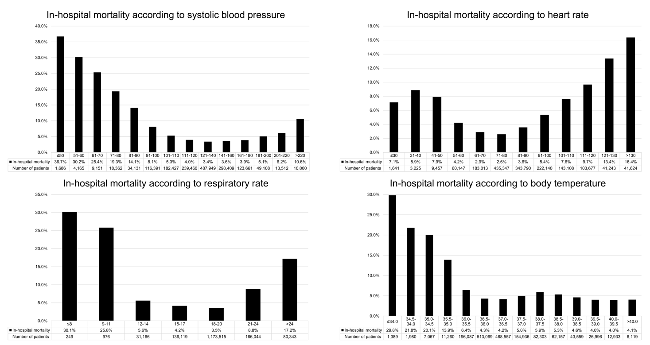
Supplementary Fig. 3. Distribution of systolic blood pressure, heart rate, respiratory rate, and body temperature.

